Modified DACUM Research Chart  Cosmetologist  CIP 12.0401  DACUM Panel  Representing 188 years of experience in Cosmetology  Melissa Blair, Program Director  Laurel Technical Institute, Hermitage, PA  Kerry Conklin, Owner  Be Styled Salon, Edinboro, PA  Darlene Newell, Cosmetology Instructor  Erie County Technical School, Erie, PA  Diana Noé, Co-Owner, Noé-Noonan Cosmetology School, Erie, PA  Kayla Noonan, Co-Owner, Noé-Noonan Cosmetology School, Erie, PA  Julie Petrick, Cosmetology Educator/Program Supervisor  Erie High School, Erie, PA  Observers and Facilitator  Susan Bogert, Supervisor of Vocational Education  Corry Career & Technical Education Center, Corry, PA  Jan Kennerknecht, DACUM Facilitator  Kennerknecht Consulting, Edinboro, PA  Tiffany Lindsey, Cosmetology Instructor, Corry Career & Technical Education Center, Corry, PA |  | 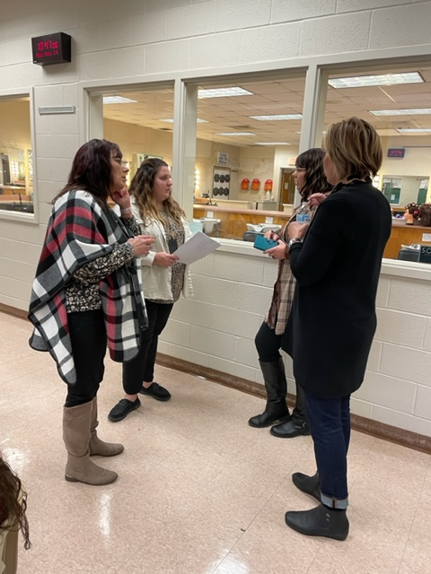  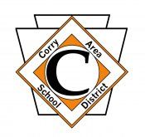  Sponsored by  Corry Area School District  Career & Technical Education Center  Produced by  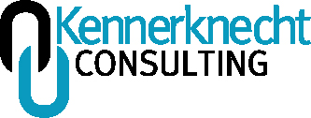  November 14, 2022

General Knowledge

All technical skills
Consumption, cost factors
Customer service
Ergonomics
Hair
How to conduct consultations
Industry standards
Knowing how to keep you and your customers safe
Knowing the laws and proper infection control (microbiology)
Nails
Positive affirmations with clients
Professional ethics
Proper protocols for disinfection
Safety for Cosmetology
Sanitation
Skin
State Board of Cosmetology laws
The salon business

General Skills

Ability to break down information to the client
Able to stand/long periods of time
Basic life skills (i.e., laundry, cleaning, etc.)
Can balance a checkbook
Collects money, balances drawer
Communication skills
Customer service skills
Finger dexterity
Leadership skills
Listening skills
Math skills (i.e., basic costing calculations, addition, subtraction, percentages, multiplication, measurement, reading a ruler, geometry angles, perpendicular, horizontal, parallel, etc.
Multi-tasking skills
Organizational skills
Problem Solving skills
Reading and writing skills (basic)
Soft skills – people, professionalism, and ethics
Student manager of clinic
Teachable
Teamwork
Time management skills

Worker Behaviors

Accepts constructive criticism
Active listener
Analyzes face shape
Assesses client needs
Calculates
Cleans as they go
Confident
Cooperative
Creative
Dedicated
Demonstrates or explains skills to clients
Dependable
Differentiates, shows depth of knowledge
Displays a great attitude
Displays professional appearance
Displays stamina
Empathetic
Enthusiastic
Examines
Flexible
Kind
Oversees or mentors newer employees or students
Passionate
Performs or executes
Plans out blueprint or draws work
Prepared
Prompt
Punctual
Reliable
Shows initiative
Team player
Willingness to continue to learn
Works well with others

Current Trends

Aromatherapy
Balayage
Blow outs- partial relaxing of curls, fuller hair
Box braids
Brow Tint and Lift, all aspects of Esthetics is growing at a very fast pace.
Cultural differences
Dip nail services
Disconnected layers
Exposure to med spa services
Eyelash Lift and Tint
Fashion hair color
Foilyage
Gel X nails (Soft gels)
Green salon or schools (healthy, natural, fewer chemicals)
Hair extensions
Inclusion and diversity, i.e., gender neutral (use 2022 edition of Milady)
Influencers on social media
Lashes
Makeup education
Nail art accents (designing, crystals)
Party colors, fun hair color treatments
Rocking their own curls
Shellac nails
Spa facials vs. treatments
Textured hair, ethnic
Threading for hair removal
Wolf haircut
Women’s short haircuts

Future Directions

Cosmetologists are more in demand than ever.
More independent self-employment, more niche area focal point salons.
Sola Salons is coming to Peach Street in Erie- booth or smaller space can be rented by small business. Salon license will be individual. Day spa experience, targeted services.
There will be more independent hair, nail and esthetician salons.
We will see more med spas (i.e., Glow Med Spa, Rejuve, Aqua Glow facial, Botox, treatment of varicose veins, collagen, hair transplants)

Concerns

Attitude- verbal skills are deficient (people being anti-social face-to-face)
Delayed adolescence gap (due to helicopter parents)- conflict resolution is affected.
Former age differences, mile markers, such as driving at 16 not seen as often.
Learning loss due to COVID-19 pandemic
Renovations/construction causing upset to classroom, disruptive to curriculum
Social media and photoshopping giving clients unrealistic hair goals
State Board lowering the standard and not holding people accountable, which drops the bar in all areas.
Student mindset- there is a setback from the pandemic (i.e., loss of family members, increased anxiety, fewer coping skills)

Certifications Recommended

State Board of Cosmetology license
Brand certifications
Hair extension certification
Nail certification, (i.e., CND)
S/P2 Cosmetology Safety
OSHA 10-Hour certification, Cosmetology field
Barbicide certifications (Barbicide and Barbicide COVID-19)
Nova Lash certification
Balayage
Any certifications pertaining to the products and services their potential salons could offer. This could be but not limited to, Lash/Brow tint and lift services, Color Certifications in color line, Brazilian blowout certification or a line similar.

Recommendations for the Program

Closed cabinetry would be better for storage.
Contact Julie Petrick for photos of career posters.
Ensure students are strong in fundamentals of hairdressing, so they can build soundly as they progress.
Full length mirrors with vertical LED lights would be better for stations.
Get nice carts for students to work from (i.e., rolling makeup train case).
Lockers in the hall are a good idea.
Order pedicure stools.
Take advantage of brand certifications, for example, Brazilian Blowouts, Sun Lights Balayage by Candy Shaw and other free certifications to build your students’ portfolios.
Use old, bald mannequins to have students draw anatomy/physiology with markers- muscles, nerves, etc. Can use mannequin hands for same purpose. Contact Melissa Blair to obtain mannequin heads.
Utilize Essential Companion as a teacher resource with Milady text (2022 version, 14th edition)

Advice for Students from DACUM Panel Members

Kerry Conklin, Owner, Be Styled Salon: “Always have a willingness to learn. Be patient with yourself as you build your clientele following.”

Darlene Newell, Cosmetology Instructor: “There is no guess work in Cosmetology. You either know it or you don’t. This goes for both theory as well as your skill set.”

Diane Noe, Owner/School Director and Kayla Noonan, Owner/School Supervisor: “You are never perfect, and you are never done learning in this industry, stay open minded so you can grow and progress.”

Julie Petrick: “Think out of the ‘now’. Where do you see yourself in 5 or 10 years? What do you want to have by then?”

Melissa Blair, Program Director: “Embrace everything. Learn everything we can teach you. You can pick and choose what you want to do later. (Specialize).”

Tiffany Lindsey, Cosmetology Instructor: “Time is money. There will be a paycheck at the end of the week when you are in the workforce.”

Acronyms

BA Beauty Advisor
COVID-19 Coronavirus Disease of 2019
DACUM Developing a Curriculum
LED Light Emitting Diodes
OSHA Occupational Safety and Health Administration
PHS Professional Hair Dresser
S/P2 Safety and Pollution Prevention

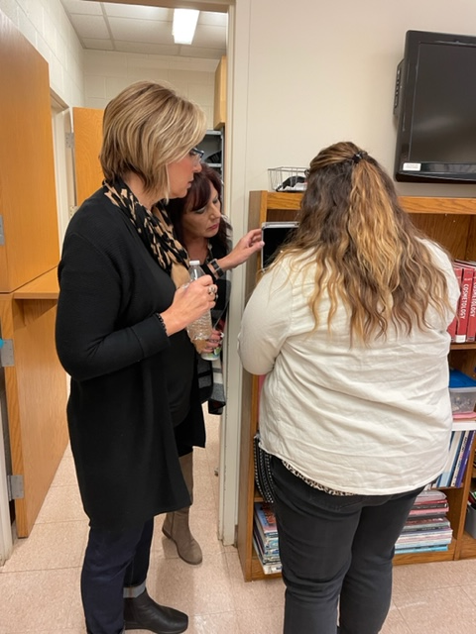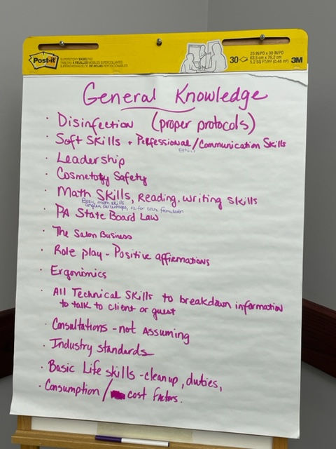

Program-Related Job Opportunities for Students

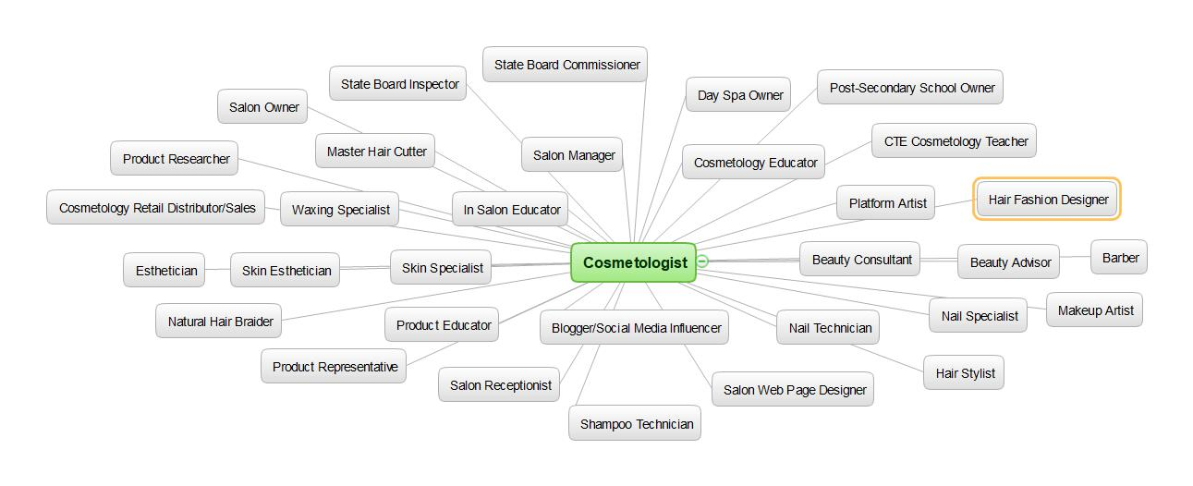

These are just some of the opportunities for graduates of the Cosmetology program!

*See attached Pennsylvania Cosmetology Task List for additional local tasks added by the DACUM panel. The Corry Area School District Career & Technical Education Center would like to thank this dedicated panel of professionals for providing their expertise. All input will be analyzed for program improvement.

